CSE445 – **Machine Learning**

Assignment 1



**Department of Electrical and Computer**

**Engineering**

**Tasks:**

1. Implementing a system that performs gradient descent to build a linear regression model  
2. Testing Linear Regression (LR) on datasets

Group Members :

1.Nafis Tanjim

(1811648642)

2.Basma Binte Azmal

(1811395642)

3.Atif Karim

(1921398042)

Introduction:

For this project, I was asked to experiment with real datasets and investigate how machine learning algorithms can be used to find patterns in data. I was expected to have experience in general data mining and machine learning. It was expected to provide a report on the dataset and algorithms used. Here is my final report after completing the required tasks on the selected dataset.

Machine learning is a sub-domain of computer science which evolved from the study of pattern recognition in data, and also from the computational learning theory in artificial intelligence. It is the first-class ticket to most interesting careers in data analytics today. As data sources proliferate along with the computing power to process them, going straight to the data is one of the most straightforward ways to quickly gain insights and make predictions. Machine Learning can be thought of as the study of a list of sub-problems, viz: decision making, clustering, classification, forecasting, deep-learning, inductive logic programming, support vector machines, reinforcement learning, similarity and metric learning, genetic algorithms, sparse dictionary learning, etc. Supervised learning, or classification is the machine learning task of inferring a function from a labeled data. In Supervised learning, we have a training set, and a test set. The training and test set consists of a set of examples consisting of input and output vectors, and the goal of the supervised learning algorithm is to infer a function

that maps the input vector to the output vector with minimal error. In an optimal scenario, a model trained on a set of examples will classify an unseen example in a correct fashion, which requires the model to generalize from the training set in a reasonable way. In layman’s terms, supervised learning can be termed as the process of concept learning, where a brain is exposed to a set of inputs and result vectors and the brain learns the concept that relates said inputs to

outputs. A wide array of supervised machine learning algorithms is available to the machine learning enthusiast, for example Neural Networks, Decision Trees, Support Vector Machines, Random Forest, Naïve Bayes Classifier, Bayes Net, Majority Classifier etc.

Each has their own merits and demerits. There is no single algorithm that works for all cases, as merited by the No free lunch theorem. In this project, we try to find patterns in a dataset.

Linear Regression

Linear Regression is a supervised machine learning algorithm. It executes a regression operation. Regression uses independent variables to model a desired prediction value. It is mostly used to determine how variables and forecasting relate to one another. Regression models vary according to the number of independent variables they use and the type of relationship they take into account between the dependent and independent variables. The mathematical technique used in linear regression models is straightforward and can be used to make predictions. Numerous corporate and academic disciplines can benefit from the use of linear regression. From the biological, behavioral, environmental, and social sciences to business, linear regression is employed widely. Future predictions can be made scientifically and highly reliable using linear regression models. The features of linear regression models are well understood. They can be trained highly quickly since linear regression is a statistical technique that has been around for a long time.

In linear regression, the model seeks to obtain the regression line that best fits the input value to predict the value of y. (x). The model calculates the cost function, which assesses the Root Mean Squared Error between the Predicted Value (pred) and True Value during training (y). The model will minimize the cost function. To minimize the cost function, the model must have the best values for 1 and 2. The model randomly chooses values for 1 and 2, which are then iteratively updated to reduce the cost function until it is at its smallest. The model will have the best 1 and 2 values after it reaches the minimal cost function. The model predicts the value of x as well as it can using these final updated values for 1 and 2 in the hypothesis equation of the linear equation.

Gradient Descent

The main goal of gradient descent algorithm is to minimize the cost function using iteration till the function is close to or equal to zero, the model will continue to adjust its parameters to yield the smallest possible error. To achieve this goal, it performs two steps iteratively:

* Calculates the first-order derivative of the function to compute the gradient or slope of that function.
* Move away from the direction of the gradient, which means slope increased from the current point by alpha times, where Alpha is defined as Learning Rate. It is a tuning parameter in the optimization process which helps to decide the length of the steps.

loss function refers to the error of one training example, while a cost function calculates the average error across an entire training set.

The main objective of gradient descent is to minimize the cost function or the error between expected and actual. To minimize the cost function, two data points are required:

* **Direction & Learning Rate**

These two factors are used to determine the partial derivative calculation of future iteration and allow it to the point of convergence or local minimum or global minimum.

Why GD for LR

Basically, the Gradient Descent algorithm is generated optimized technique so that it can be used to optimize any cost function. It is often useful when optimum point cannot be estimated in closed form solution.

Gradient Descent is the improved algorithm of machine learning that is used to minimize the various machine learning algorithm’s cost function (errors between actual and expected result), updating the parameters of the learning model.

As the gradient descent is a general algorithm, one can apply it to any problem that requires optimizing a cost function. In the regression problem, the cost function that is often used is the mean square error (MSE).

**Code instruction:**

**MSE = $\frac{1}{n}\sum_{i=0}^{n}{(y_{i}-y_{pred}})^{2}$**

MSE = Cost Function

$y_{i}$ = Original Output

$y_{pred}$ = Predicted Output

We will predict using equation, \

Y= mx+c

m= slope

x= feature value

c=intercepted point on y axis

**MSE = $\frac{1}{n}\sum_{i=0}^{n}{(y_{i}-(mx_{i}+c)})^{2}$**

Initially,

m= 0

c is 0

L= Learning rate = depends on the coder

Learning Rate means how much m and c changes in each step. For the good accuracy Learning Rate should be too small (such as 0.0001) so that it can take lots of iterations to get to the accurate value. After every iteration MSE value will be updated along with m and c.

Target is to find the global minima where MSE is so much less and the values of m and c are better.

We need to differentiate MSE with respect to m and c.

Differentiation of COST function with respect to m,

$\frac{d(MES)}{dm}$ = Dm= $-\frac{2}{n}\sum_{i=0}^{n}{x_{i}(y_{i}-y_{pred}})$

Differentiation of COST function with respect to c,

$\frac{d(MES)}{dc}$ = Dc= $-\frac{2}{n}\sum_{i=0}^{n}{(y_{i}-y_{pred}})$

Updated value of m,

m(new)= m(old) – L × Dm

Updated value of c,

c(new)= c(old) – L × Dc

**The codes we have written:**

Gradient Descent to built Linear Regression Model

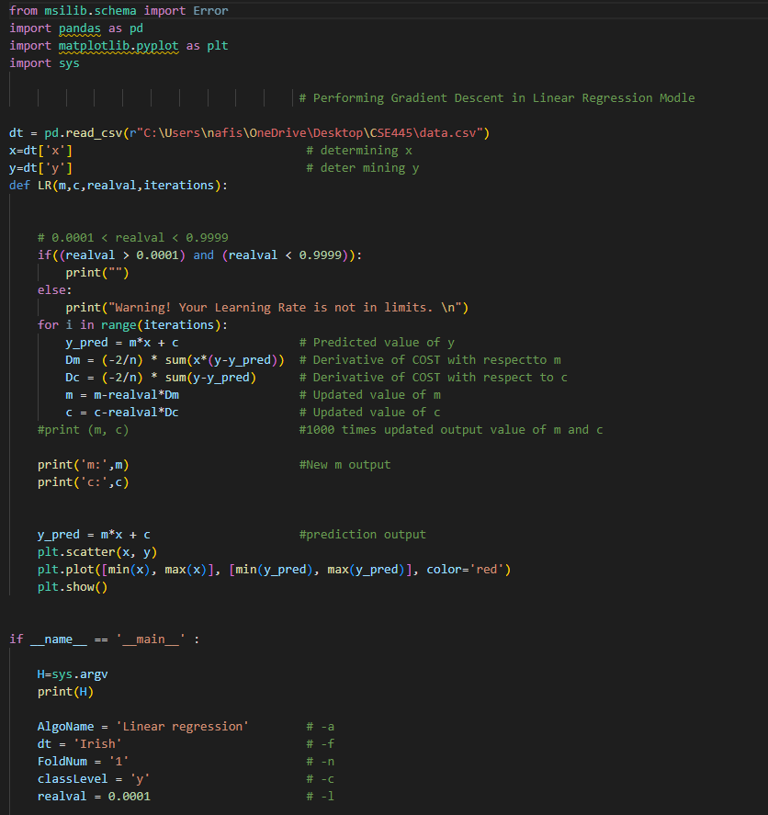

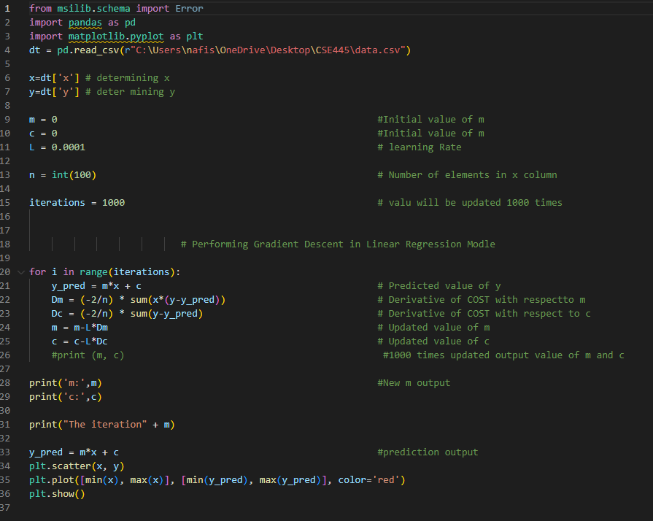

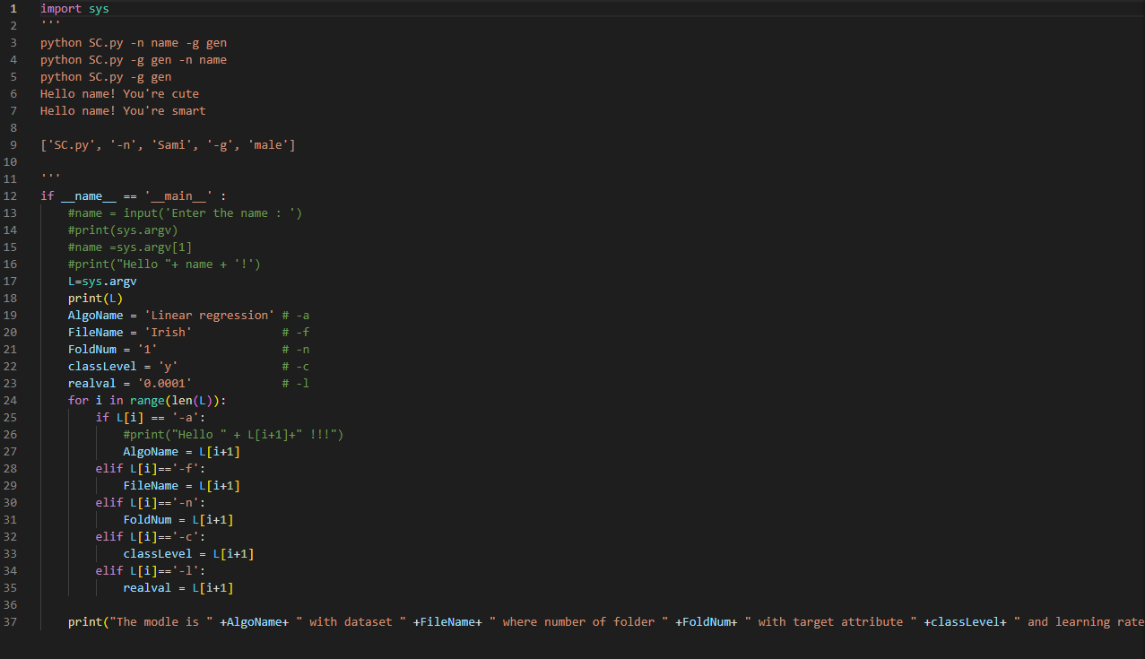

Expected Output:

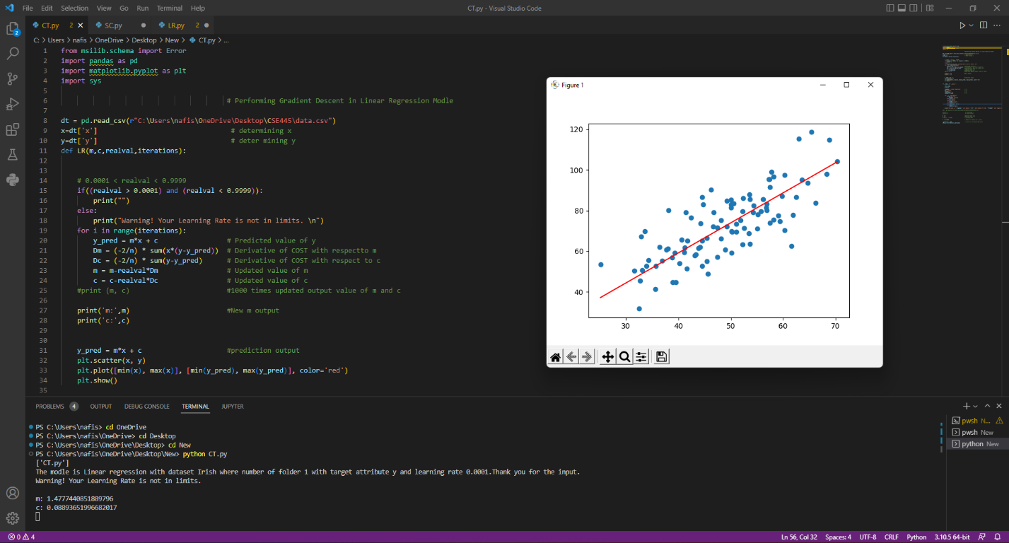

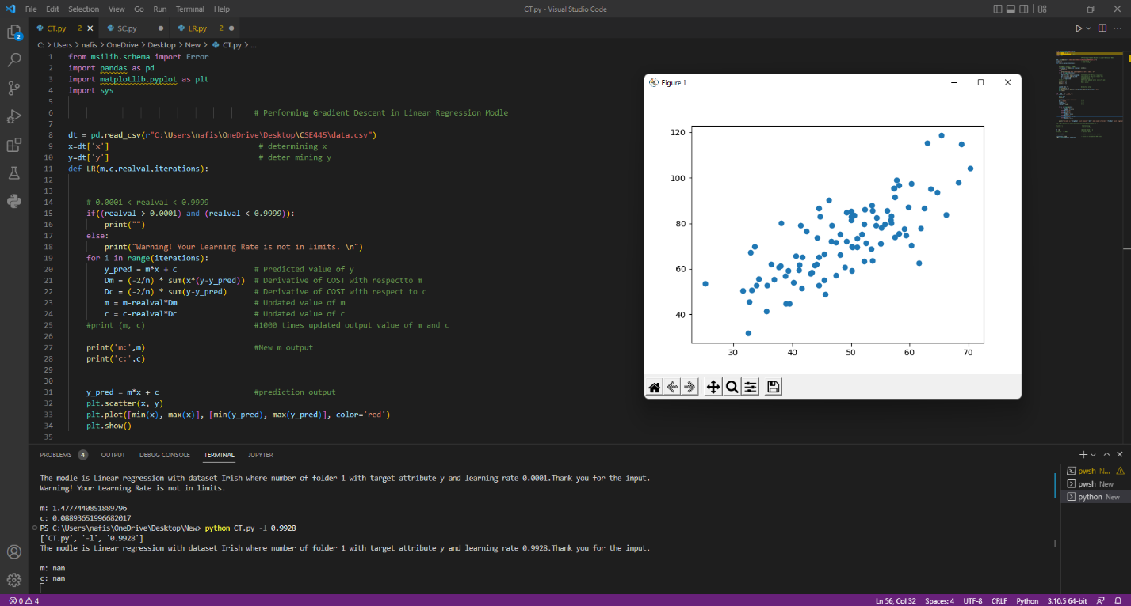

Testing dataset:

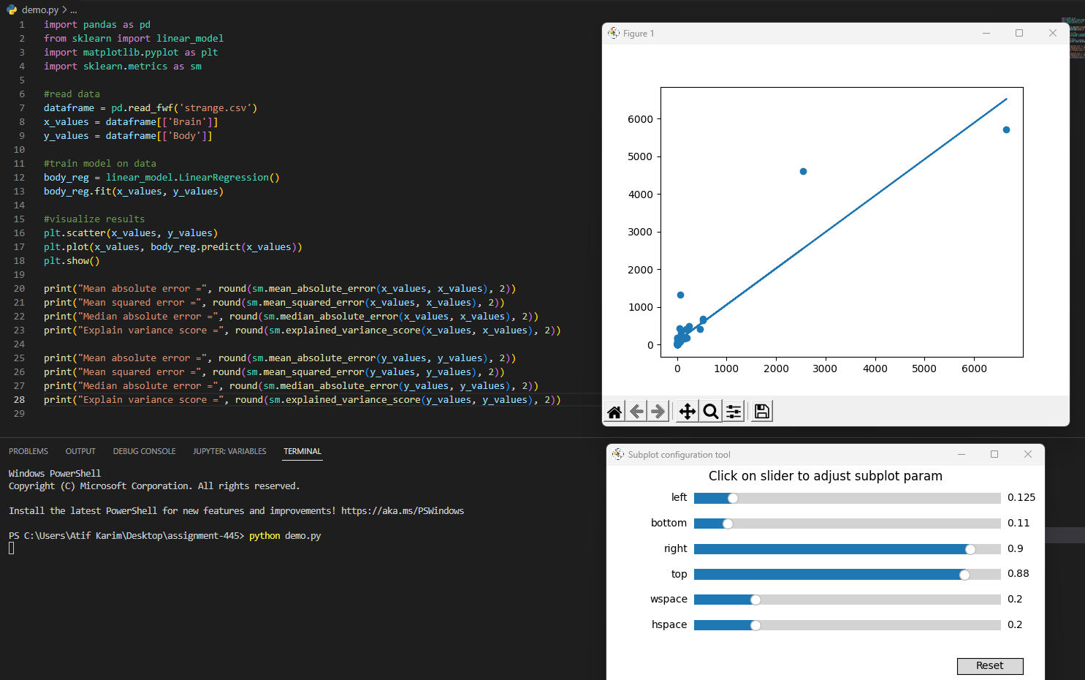

These are our python code that use he file named data.csv to comb through each data and perform linear regression to give us a value.

Conclusion:

The following task helped me to learn about,

Theoretically:

* Gradient Descent
* Linear Regression
* Preforming Gradient Descent to built a Linear Regression model

Practically:

* Exception Handling
* Configuring switch to regulate the model
* How to work in console

All these topics enhanced my knowledge and inspired me to learn more about machine learning. As machine learning is the future of the existing technologies, I think every engineering students should learn about this.